**Project Two**

Tim Brady

Southern New Hampshire University

CS-340: Client/Server Development

Professor Paruchuri

June 18, 2023

**Project Two**

**Grazioso Logo**

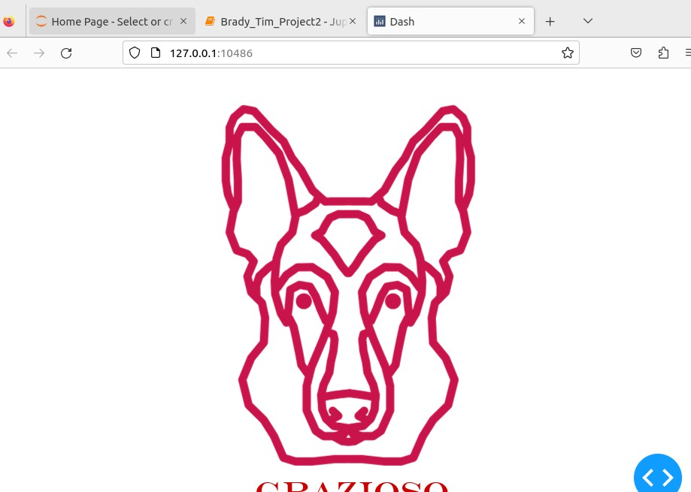

**Unique Personal Identifier**

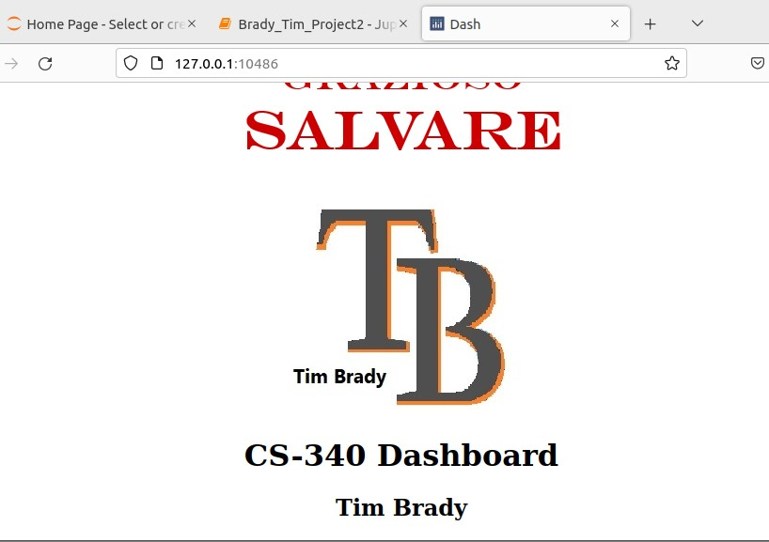

**Dashboard Table Screenshots**

**Reset Filter**

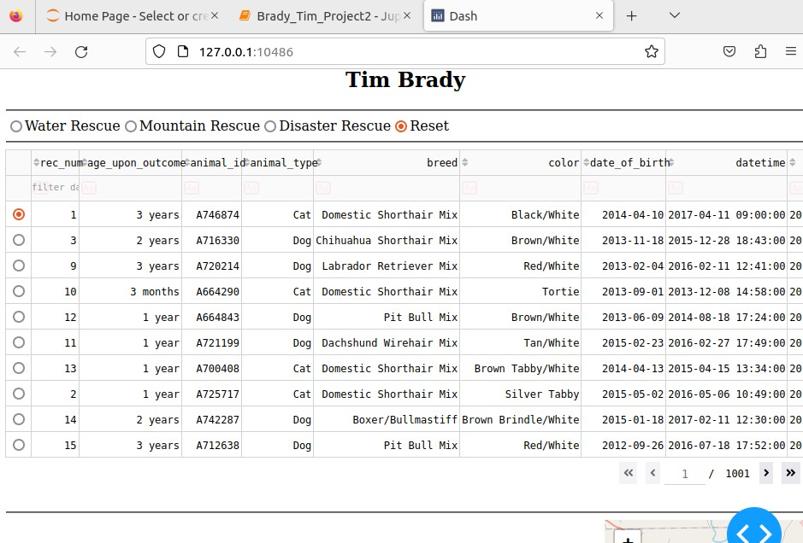

**Disaster Rescue Filter**

**Mountain Rescue Filter**

**Water Rescue Filter**

**Graph and Map With Moving Pin**

**Pin for Animal 3130**

**Pin for Animal 6021**

